Instructions on How to Create a Sales Invoice Form in the Access Project
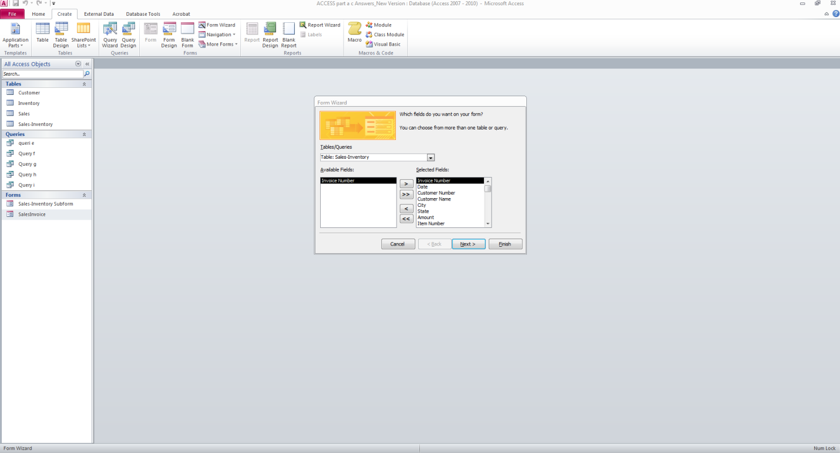
Step 1: Create->Form Wizard to select all items in the sales invoice.
Step 2: Click Next. Please check whether you have the same screen as I have here (Especially the one I highlight here. If not, double check the relationship (Database Tools-Relationship) for primary keys, the fields used to link tables, the data type of these fields used to link tables, etc.
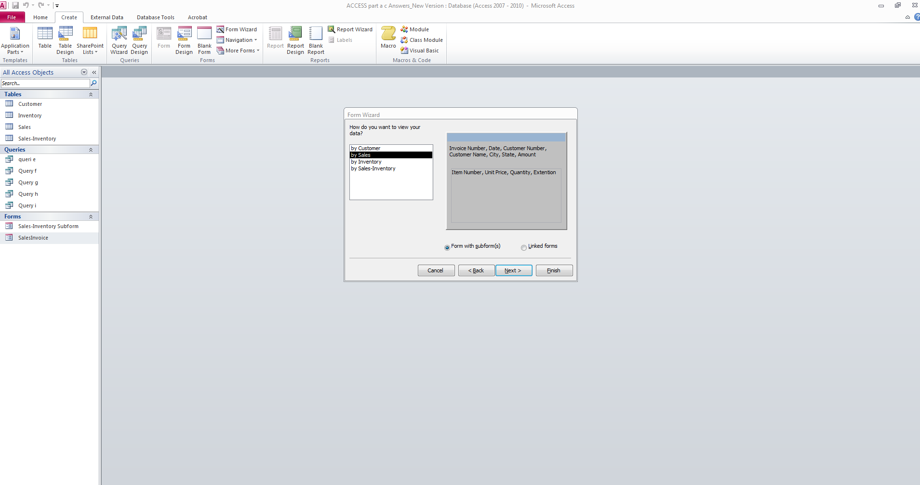

Step 3: Click Next
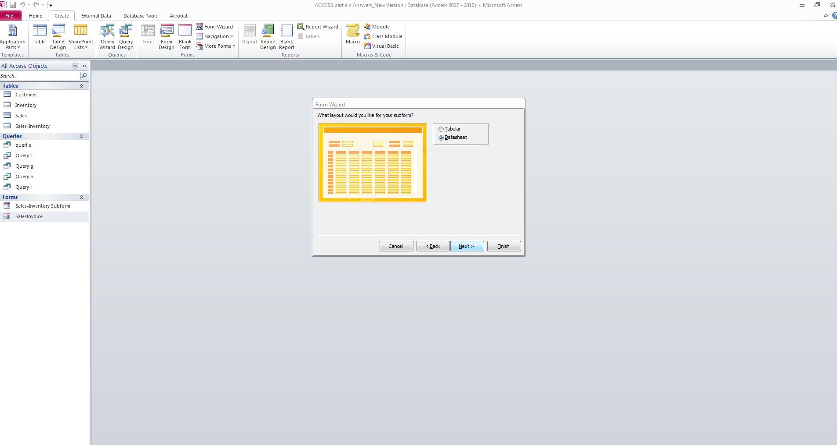
Step 4: Click Next
